**Rebecca Birkett | Music player Documentation | user guide**



‘Home menu’

# Rebmem music player user guide

The REBMEM music player is pre-installed with the necessary software required for everyday function, therefore no additional downloads are necessary.

Please ensure that the device is fully charged before using it for the first time.

Once fully charged, power on the device. You will be presented with the ‘home menu’, with three options to choose from. From left to right, the options are ‘search’, ‘songs’ and ‘playlists’.

## Installing music files

There are five music files pre-installed onto the device, which you may remove if you so wish. To add your own songs, connect the device to a computer or laptop via the USB cable provided. Please note that the device you are connecting the music player to must be pre-installed with (at minimum) Windows 10 Professional (x64).

1. Connect the device to a USB port on your computer or laptop.
2. Open Windows file explorer.
3. In the navigation menu on the left, find ‘REBMEM Music Player’ under your devices.

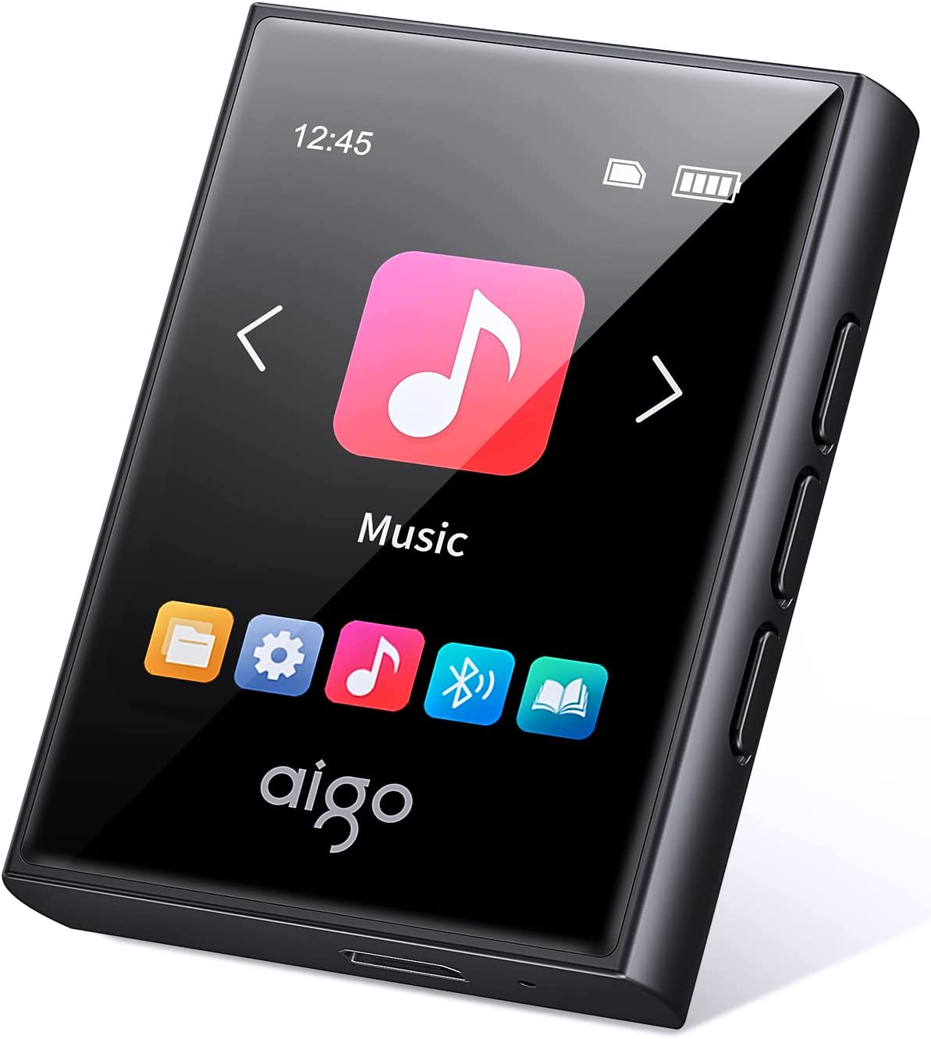

[Example music player](https://www.amazon.co.uk/aigo-Bluetooth-Portable-Lossless-Recorder/dp/B0B67S1DBK/ref=sr_1_5?c=ts&keywords=MP3+&+Digital+Audio+Players&qid=1663152722&s=network-media&sr=1-5&ts_id=573372)

1. Open this folder, you will now be in the home directory of the music player.
2. Open a folder called ‘musicfiles’. If this is your first time using the device, there will be 5 files inside.
3. To add songs, you can either copy and paste the files or drag them in from another directory.
4. Once finished, **safely eject the device** from your computer or laptop and remove the music player.

## Listening to music

Please ensure the device is powered on. If so, you will be presented with the ‘home menu’, with three options to choose from. From left to right, the options are ‘search’, ‘songs’ and ‘playlists’. If you are on another screen, you can return to the home menu by tapping the ‘home’ icon found in the top left corner of the screen.



Step 1 - tap the centre icon, a music note

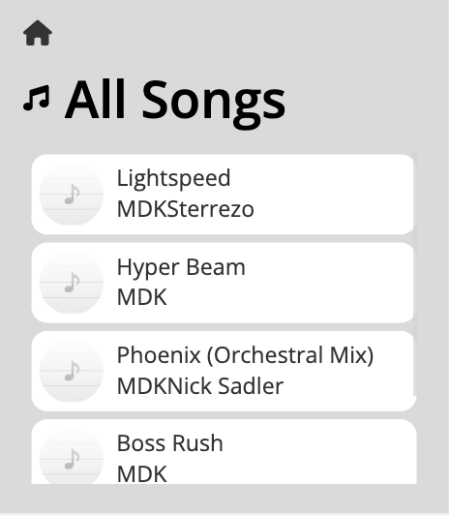

Step 2 - tap the song you want to listen to

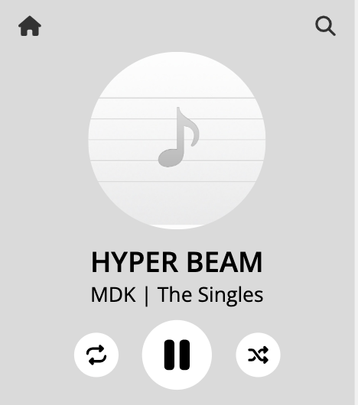

Step 3 - enjoy!

The selected song will automatically start to play when loaded into the digital music player. **You can control the volume of the current song using the volume controls on the right side of the device.**

## Controlling music



The digital audio player controller

**1**

**2**

1. Tap the ‘home’ icon to return to the ‘home page’

2. Tap the ‘search’ icon to navigate to the ‘search’ page

**3**

3. This is the album art for the currently playing audio track

4. This is the title of the currently playing audio track

**4**

5. This is the artist and album of the currently playing audio track

**5**

6. Tap the ‘loop’ icon to indefinitely loop the currently playing audio track. This will toggle to a ‘single play’ icon to return to one-time playback.

**6**

**7**

**8**

7. Tap the ‘pause’ icon to pause the current audio track. This will toggle to a ‘play’ icon to allow for usual audio playback.

8. Tap the ‘shuffle’ icon to automatically skip to a random audio track

## Creating playlists

If you are on another screen, you can return to the home menu by tapping the ‘home’ icon found in the top left corner of the screen. To go to the playlists menu, tap the right-most icon, the ‘lists’ icon.



Step 1 - tap the right-most icon, a list

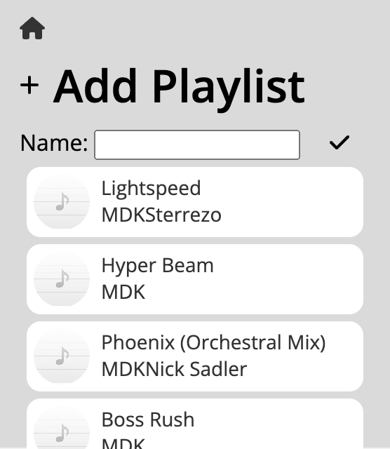

Step 3 - type a name for your playlist and tap the tick to confirm!

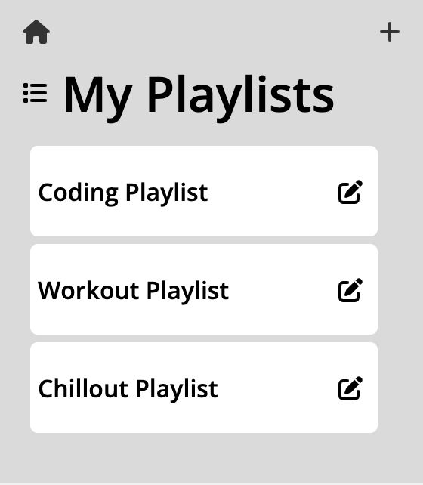

Step 2 - tap the plus icon on the top right corner

## Editing playlists

If you are on another screen, you can return to the home menu by tapping the ‘home’ icon found in the top left corner of the screen. To go to the playlists menu, tap the right-most icon, the ‘lists’ icon. From there, you will see a list of existing playlists. To edit a playlist, tap the pencil icon to the right of the corresponding playlist.



Step 1 - tap the pencil icon to the right of your chosen playlist

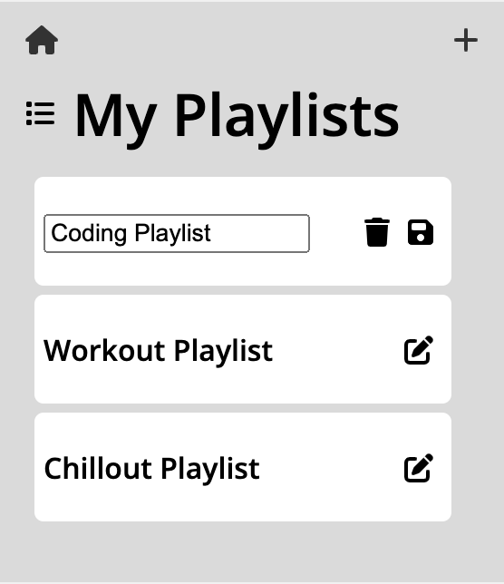

Step 2 - type a new name for your playlist and tap save!

**TIP!**

You can also delete a playlist from here! Just tap the ‘trashcan’ icon!

## Idle mode

**Please note!** To conserve battery, your device will automatically go into an ‘idle’ state after 30 seconds of inactivity. This means that the screen of your device will go blank, however you are still able to listen to music!

To exit idle mode, simply tap anywhere on the screen and your device will return to normal.